Advent Shawl (4ply Yarn)
Pattern by PipsRainbow
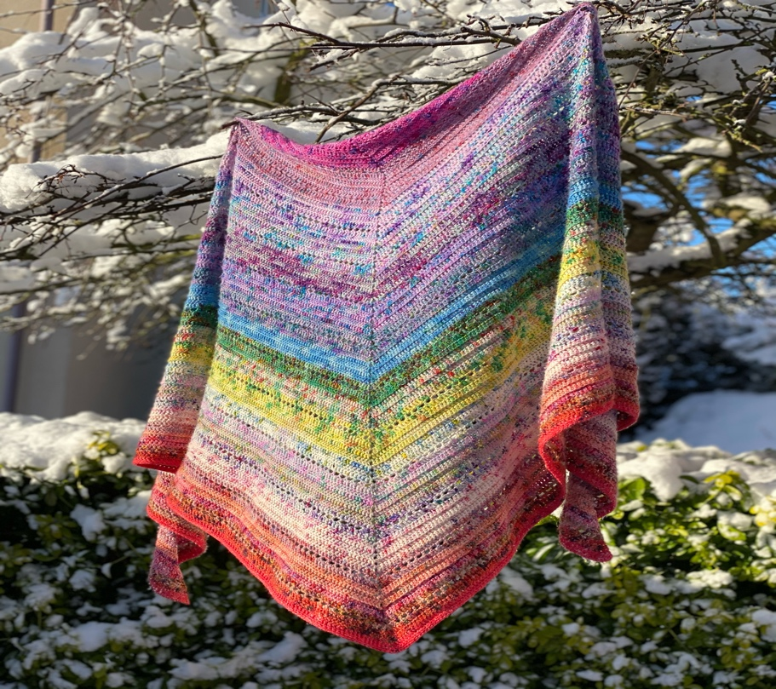

I just love a rainbow. I’m not sure why I like them so much. Maybe it’s the way the colours sit so beautifully with each other & how they sing. They are just so magical. So it was only a matter of time before I designed a rainbow shawl. So when I saw my colours evolving in front of me from my Orchidean Luxury Yarn Advent calendar - I just knew it had to be done. This utterly, gorgeous yarn, gives this shawl an extremely soft & sumptuous feel. The pattern follows an 8 row repeat, creating a beautiful & elegant shawl.

Level – Medium

Yarn – 450g of 4ply yarn. You can use any colour way that you like. I decided to create mine into a rainbow effect using my advent yarn, but you can work it up in any colour way that you like. (It even goes well in one variegated colour.)

Hook
4mm crochet hook

Notions -
Scissors, darning needle for sewing in ends.

Finished size -
Wingspan – 280cm Centre spine depth – 120cm
It uses 13 times 8 row repeats plus border. (You can create this scarf in any size you like. Just adapt the pattern by using increasing or decreasing the number of 8 row repeats.)

Fasten off - slip stitch into the last stitch you have worked, pull through & cut yarn.
Attach yarn – Insert hook into the stitch, new yarn over hook & pull through the stitch.

Abbreviations –
mr – Magic Ring
ch – Chain
ch2sp – Chain 2 Space
dc - Double Crochet
htr - Half Treble Crochet
blhtr - Back Loop Half Treble Crochet
tr - Treble Crochet
bltr –Back Loop Treble Crochet

Pattern –

1 – Make a mr, ch3, then work 3tr into the ring, then ch2 & work 4tr stitches into the ring. Then pull the tail tight. (I tend to make a little knot here, to keep the mr closed.)

2 – Turn your work, ch3, 2tr in the first stitch, then 1tr in each tr stitch in the row. Then work 1tr, ch2, 1tr in the ch2sp. Work 1tr in each stitch in the row, finally working 2tr in the top of the ch3 from the previous row.

3 – Turn your work, ch3, 2tr in the first stitch, then 1tr in each stitch in the row. Then work 1tr, ch2, 1tr in the ch2sp. Work 1tr in each stitch in the row. Finally work 2tr in the top of the ch3 from the previous row.

4 – 7 (4 rows) *Turn your work, ch3, 2bltr in the first stitch, then 1bltr each stitch in the row. Then work 1tr, ch2, 1tr in the ch2sp. Work 1bltr in each stitch. Finally work 2bltr in the top of the ch3 from the previous row.* Work ** four times.

8 – Turn your work, ch3, 2tr in the first stitch, then 1tr in each stitch in the row. Then work 1tr, ch2, 1tr in the ch2sp. Now work 1tr in each stitch in the row. Finally work 2tr in the top of the ch3 from the previous row.

9 – Turn your work, ch3, work 2tr in the first stitch. *Now ch1, miss 1 stitch & work 1tr in the next stitch.* Work ** across the row. Then work 1tr, ch2, 1tr in the ch2sp. Now work 1tr in the first stitch. *Now ch1, miss 1 stitch & work 1tr in the next stitch.* Work ** across the row. Work 2tr in the top of the ch3 from the previous row.

10 – Turn your work & ch3. Now work 2tr in the first stitch, then 1tr in the next 2 stitches. Work 1tr in the first ch1sp. *Now work 1tr in the next stitch & in the next ch1sp.* Work ** across the row. Finish the row with 1tr in the last 2 stitches. Work 1tr, ch2, 1tr in the ch2sp. Then work 1tr in the first stitch in the row. *Now work 1tr in the next stitch, then 1tr in the next ch1sp.* Work ** across the row. Finish the row by working 1tr in the last 2 stitches, then 2tr in the top of ch3 from the previous row.

Now it’s time to repeat the last 8 rows. So repeat rows 3 – 10, 12 more times.

Border –
1 – 2 (2 rows) *Turn your work, ch3, 2tr in the first stitch, then 1tr in each stitch. Then in the ch2sp work 1tr, ch2, 1tr. Now work 1tr in each stitch in the row. Finally work 2tr in the top of the chain 3 from the previous row.* Work ** twice.

3 - Now turn your work, ch1, 2dc in the first stitch, then 1dc in each stitch. Work 1dc, ch2, 1dc in the ch2sp. Now work 1dc in each stitch in the row. Finally work 2dc in the top of the chain 3 from the previous row.
4 - This is your final row. Turn your work, ch2 & work 2blhtr in the first stitch, then work 1blhtr in each stitch in the row. Work 1htr, ch2, 1htr in the ch2sp. Now work 1blhtr into each stitch in the row, finally working 2blhtr in the top of the chain 1 from the previous row.

Finishing off –
Now it’s time to sew in your ends using a darning needle & block your finished shawl. I tend to use sponge floor tiles and long headed/T pins for this.

I really hope you have enjoyed this pattern. My Advent Shawl comes everywhere with me. It has been used as a shawl, scarf, a blanket to keep little ones warm & even in a rescue mission with a dog lead once! Don’t ask!! Haha, you can safely say that I love it & will be treasured forever.

Care – When washing, ensure you follow the instructions on the label of the yarn you are using & be as gentle as you can. Once gently washed, I will always reshape mine back into place.

Don’t forget to share any pics with us of your fabulous shawl on the good old fashioned net. Tag us in on Instagram, Facebook, You Tube & Twitter @pipsrainbow & #pipsrainbow.

Happy hooking. Xx

(Please note this pattern has been test crocheted, but not tech edited. But every attempt has been made for it to be easy to follow and free from mistake. It is for personal use only. Any questions, happy to help.)

